

**Employment Outlook to November 2019**

*Based on the Department of Employment’s 2015 employment projections*

# Table of Contents

Introduction 2

Projected employment growth by industry 3

Projected employment growth by skill level 6

Projected employment growth by occupation 7

Projected employment growth by state and territory 9

Projected employment growth by region 10

Background and methodology 11

# Introduction

Employment growth in Australia has remained relatively subdued compared with the robust labour market conditions leading up to the onset of the Global Financial Crisis. Employment has increased by 780,500 (or 7.1 per cent) over the five years to June 2015, well below the growth of 1,098,900 (or 11.1 per cent) recorded over the five years to June 2010[1]. However, more recently, employment growth has improved, rising by a solid 214,900 (or 1.9 per cent) over the year to June 2015.

Over the past five years, employment growth in the Australian economy has been spread across a number of industries and occupational groups, with a handful of services (particularly Health Care and Social Assistance and Professional Scientific and Technical Services) making particularly substantial contributions to employment growth. That said, employment growth has been offset by falls in employment in Manufacturing (down by 58,500 or 6.0 per cent) and Agriculture, Forestry and Fishing (53,900 or 15.1 per cent), while the previous strong employment growth in Mining has ended with employment in the industry declining in recent years.

Looking ahead, based on the employment forecasts and projections published in the December 2014 Mid-Year Economic and Fiscal Outlook (MYEFO), total employment is projected to increase by 1,166,400 (or 10.0 per cent)[2] over the five years to November 2019 to reach 12,776,500. However, the distribution of this growth is projected to vary across industries, occupations, skill levels, states and territories, and regions. This report outlines the employment outlook across these categories, based on employment projections produced by the Department of Employment for the period November 2014 to November 2019.

**Figure 1: Employment level, past and projected growth to November 2019, Australia (‘000)**

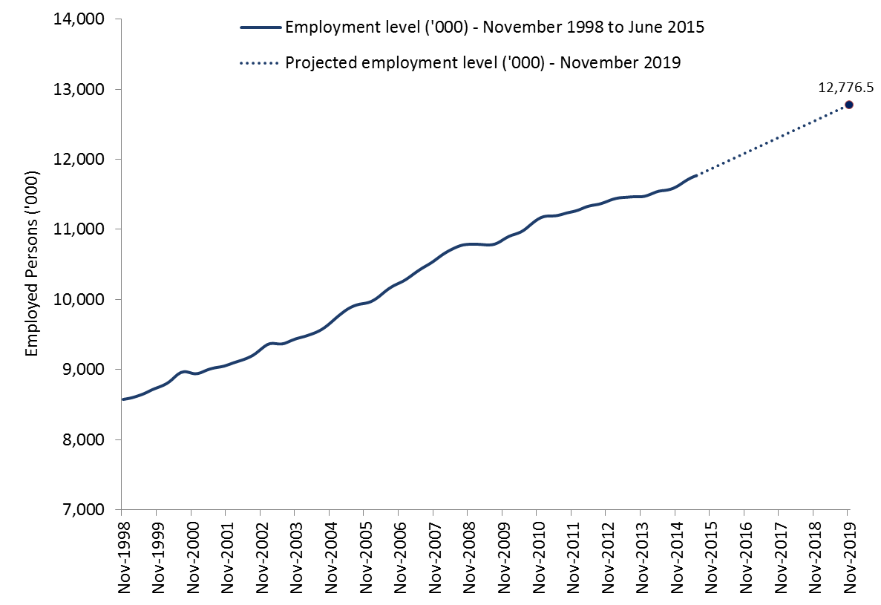

# Projected employment growth by industry

Over the five years to November 2019, employment is projected to increase in 17 of the 19 broad industry groups, with declines in employment only projected for Mining and Manufacturing. Health Care and Social Assistance is projected to make the largest contribution to employment growth (up by 258,000 or 18.7 per cent), followed by Education and Training (142,700 or 15.6 per cent), Construction (137,900 or 13.0 per cent), and Professional, Scientific and Technical Services (136,600 or 14.4 per cent). Together, these four industries are projected to provide more than half of the employment growth to November 2019.

By contrast, against the backdrop of an expected peak in capital expenditure and the transition of new mines from a construction phase to a less labour intensive operational phase, employment in Mining is projected to decline by 40,700 (or 17.8 per cent) over the five years to November 2019. In line with the long term structural change in the labour market and the announced plant closures by major car manufacturers, employment in Manufacturing is projected to decline by 26,200 (or 2.9 per cent) over this period.

**Figure 2: Projected employment growth by industry – five years to November 2019 (‘000)**

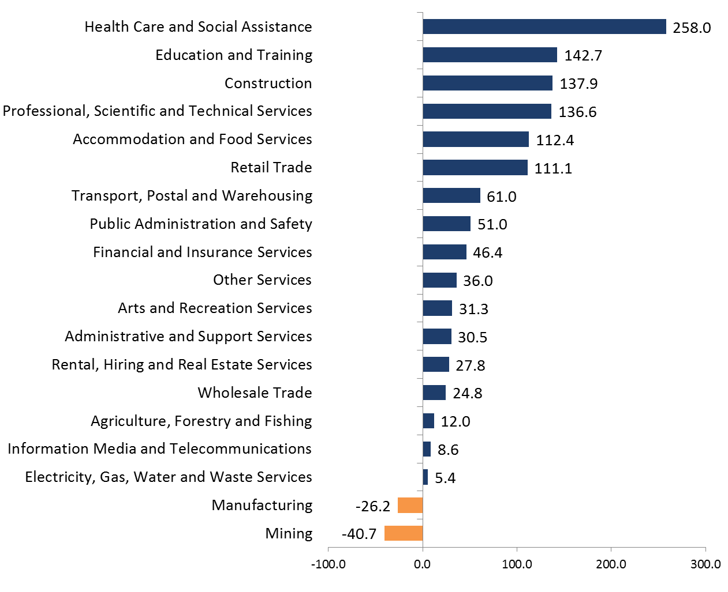

At the more detailed sector level, Australia’s largest employing industry sector - Cafés, Restaurants and Takeaway Food Services - is projected to make the largest contribution to growth over the five years to November 2019 (up by 93,600 or 16.9 per cent). The top 20 projected growth sectors generally reflect the projections at the broader industry level, with sectors in Health Care and Social Assistance and Education and Training particularly prevalent. Against the backdrop of the implementation of the National Disability Insurance Scheme, Australia’s ageing population and increased demand for childcare and home based care services, large increases in employment are projected for Hospitals (up by 53,900 or 15.2 per cent), Residential Care Services (46,700 or 21.6 per cent) and Child Care Services (37.7 per cent or 27.7 per cent). Supported by above average growth in the school aged population and continuing growth in part-time workers in the sector and non-teaching staff, strong growth is projected in School Education (up by 55,600 or 12.3 per cent), Adult, Community and Other Education (40,600 or 25.8 per cent) and Tertiary Education (36,500 or 15.6 per cent). Reflecting the large contribution to employment growth projected for the Construction industry, strong growth in employment is projected for Building Installation Services (50,400 or 20.7 per cent) and Building Completion Services (24,800 or 13.0 per cent).

**Figure 3: Top 20 industry sectors – ranked by projected growth to November 2019 (‘000)**

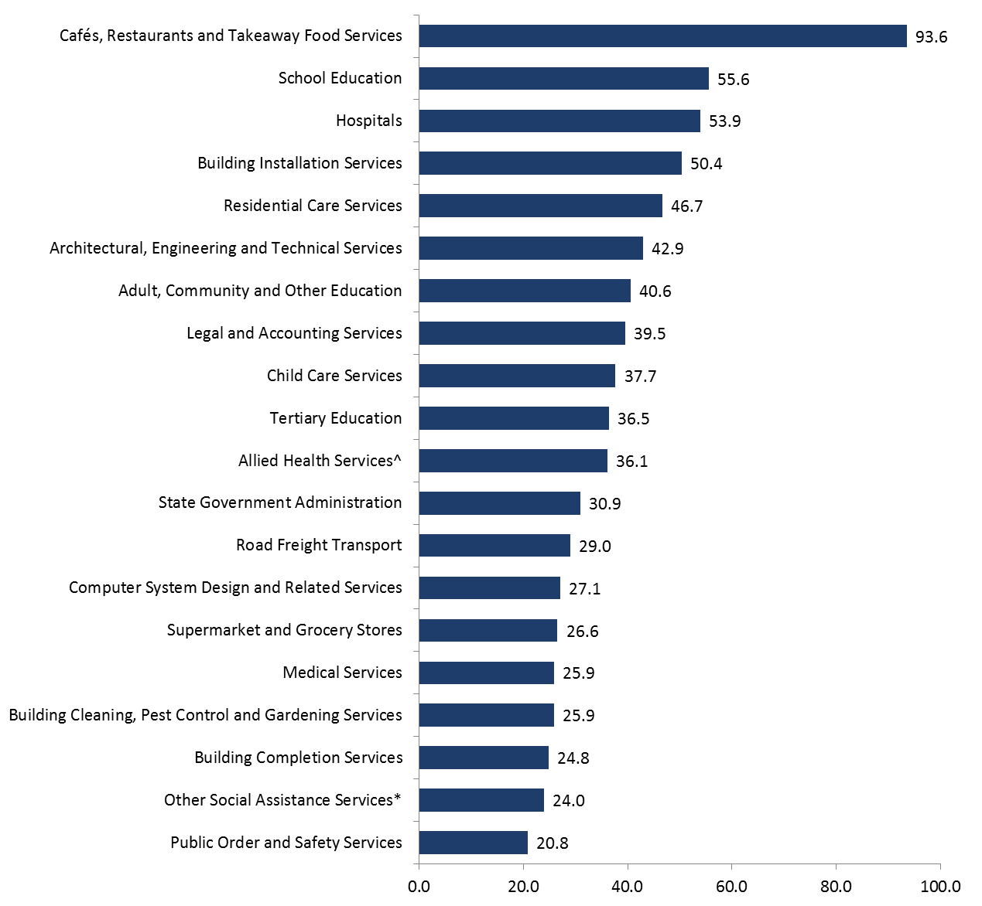

^*Allied Health Services* includes Dental Services, Optometry and Optical Dispensing, Physiotherapy Services and Chiropractic and Osteopathic Services. \**Other Social Assistance Services* includes Aged Care Assistance Services, Disabilities Assistance Services, Youth Welfare Services and Welfare Counselling Services.

A number of industry sectors are projected to record a decline in employment over the five years to November 2019. The largest fall across all sectors is projected for Motor Vehicle and Motor Vehicle Part Manufacturing[3] (down by 23,800 or 47.5 per cent), following the announced plant closures by major car manufacturers. Employment is projected to decline for a number of Mining related sectors, with the largest declines projected for Metal Ore Mining (7,600 or 13.4 per cent), Coal Mining (7,300 or 17.1 per cent) Heavy and Civil Engineering Construction (6,500 or 8.3 per cent), Other Mining Support Services[4] (6,400 or 25.2 per cent) and Exploration (5,500 or 22.0 per cent). Employment in Central Government Administration is also projected to record one of the largest falls over the period (4,900 or 4.6 per cent).

# Projected employment growth by skill level

The Australian Bureau of Statistics (ABS) classifies occupations according to five skill levels commensurate with the following qualification(s)[5]:

* Skill level 1: Bachelor degree or higher qualification
* Skill level 2: Advanced Diploma or Diploma
* Skill level 3: Certificate IV or III (including at least two years on-the-job training)
* Skill level 4: Certificate II or III
* Skill level 5: Certificate I or secondary education

The attainment of educational qualifications remains important given the strong past and projected growth of higher skilled occupations, as well as the lower unemployment rates recorded for people with higher qualifications. Over the past few decades, the Australian economy has continued to shift away from lower skilled jobs towards a higher skilled, service based economy. Looking ahead, the evolution of the labour market towards higher skilled occupations looks set to continue over the five years to November 2019, with employment growth projected to be strongest, in percentage terms, among the two highest skill levels. This highlights the importance of educational attainment not only for those in the workforce looking for career advancement, but also for potential first time labour market entrants looking to improve their employment prospects. Employment for skill level 1 occupations is projected to increase strongly by 466,700 (or 13.1 per cent) over the five years to November 2019, while skill level 2 is also projected to grow by 136,400 (or 10.4 per cent). More subdued growth is projected for skill level 3 (147,100 or just 8.3 per cent), with weak or negative growth projected for some Automotive and Engineering Trades, and Printing, Clothing and Wood Trades, as well as for Secretaries and Personal Assistants. Employment for skill level 4 is projected to increase by 299,000 (or 9.9 per cent), providing lower skilled opportunities for job seekers, while weaker growth is projected for skill level 5 (up by 117,200 or 6.0 per cent).

**Figure 4: Projected employment growth to November 2019 (‘000), by skill level**



*Includes at least two years on-the-job training.

# Projected employment growth by occupation

Employment is projected to increase in all eight of the occupational groups over the five years to November 2019. In particular, recent strong employment growth is projected to continue for Professionals (up by 376,300 or 14.2 per cent) and Community and Personal Service Workers (205,500 or 17.9 per cent). Together, these two occupational groups are expected to account for half of the total growth in employment over the next five years. Strong growth is also projected for Technicians and Trades Workers (159,800 or 9.3 per cent), Managers (146,200 or 9.5 per cent), and Sales Workers (110.400 or 10.0 per cent). Employment of Clerical and Administrative Support Workers is projected to grow by 121,400 or 7.4 per cent, below the all occupations average of 10.0 per cent. Employment growth is projected to be subdued for Machinery Operators and Drivers (25,500 or 3.4 per cent) and Labourers (21,300 or 1.9 per cent).

**Figure 5: Projected employment growth by occupational group – five years to November 2019 (‘000)**

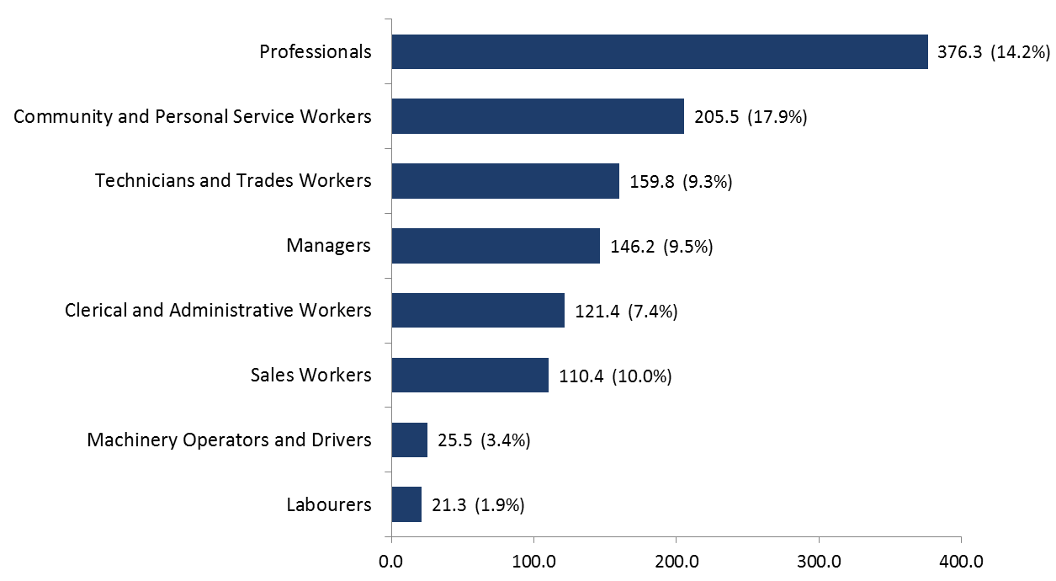

Figure 6, on the next page, shows the 20 detailed occupations that are projected to contribute the most to employment growth over the five years to November 2019. General Clerks is projected to record the largest increase in employment over the five years of any occupation (up by 75,600 or 30.0 per cent), followed by Sales Assistants (General) (58,300 or 11.5 per cent) and Registered Nurses (41,400 or 17.9 per cent). Carers and Aides are well represented amongst the top 20 occupations, with strong growth projected for Aged and Disabled Carers (26,100 or 18.5 per cent), Child Carers (22,800 or 17.5 per cent) and Education Aides (20,900 or 29.1 per cent).

**Figure 6: Top 20 occupations (Skill level) – ranked by projected growth to November 2019 (‘000)**

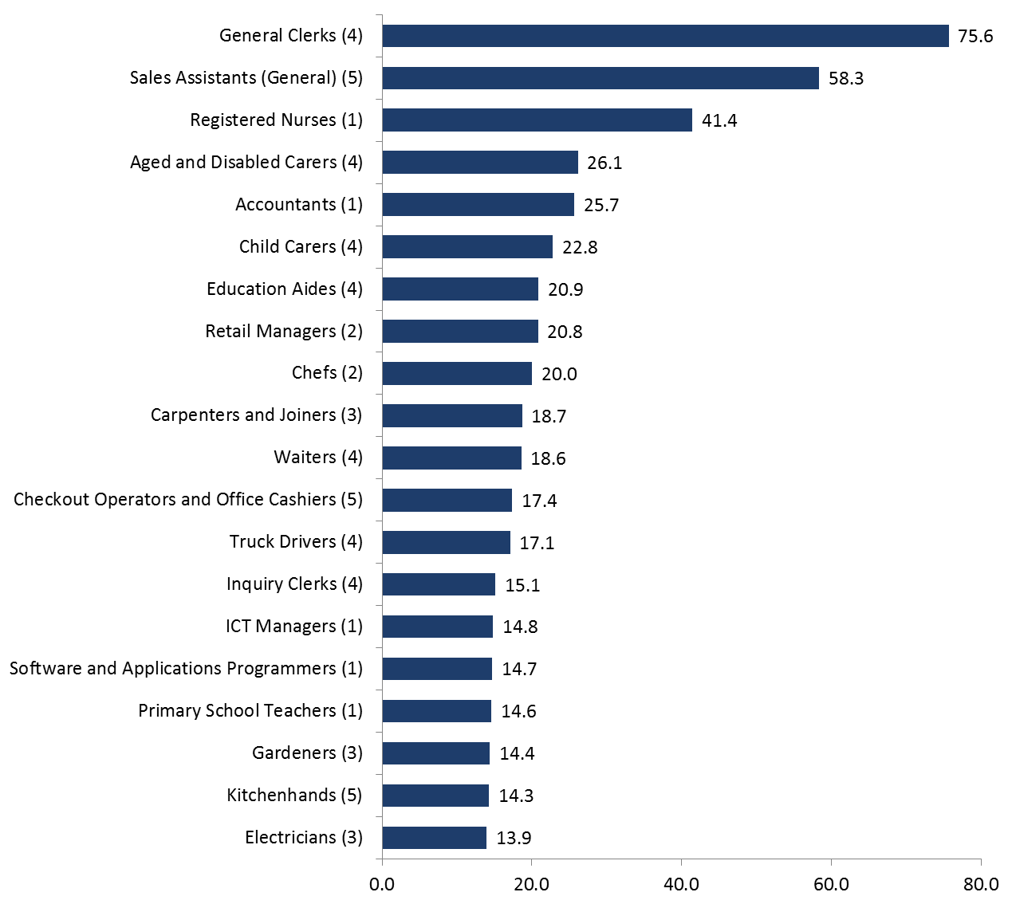

Secretaries is projected to record the largest decline in employment (11,400 or 22.3 per cent). Overall, the majority of the occupations projected to decline fall within the lowest skill levels, with eight of the bottom 10 occupations either skill level 4 or 5 (for example Drillers, Miners and Shot Firers, Product Assemblers, Packers and Crop Farm Workers), and just one occupation from the bottom 10 being skill level 1 (Engineering Managers).

# Projected employment growth by state and territory

Over the five years to November 2019, employment is projected to increase in all states and territories.

Against the backdrop of an expected decrease in Mining investment, employment growth in Western Australia and the Northern Territory is expected to slow from the rates recorded over the past five years. That said, employment growth is nonetheless expected to remain comparatively strong, with employment projected to increase by 15,100 (or 11.5 per cent) in the Northern Territory and 148,800 (or 10.7 per cent) in Western Australia over the five years to November 2019.

New South Wales, Victoria and Queensland are also projected to make large contributions to employment growth over the five years to November 2019, with employment projected to increase by 358,800 (or 9.9 per cent) in New South Wales, by 308,700 (or 10.6 per cent) in Victoria and by 243,600 (or 10.4 per cent) in Queensland.

Employment growth is projected to be more subdued in South Australia (53,800 or 6.7 per cent) and Tasmania (up by 17,800 or 7.4 per cent) over the five years to November 2019, in line with the persistence of soft labour market conditions in these states. The Australian Capital Territory (up by 19,900 or 9.3 per cent) is also projected to record a below average rate of growth, constrained by a projected slower rate of growth in Public Administration and Safety.

**Figure 7: Projected employment growth by state/territory – five years to November 2019 (‘000)**

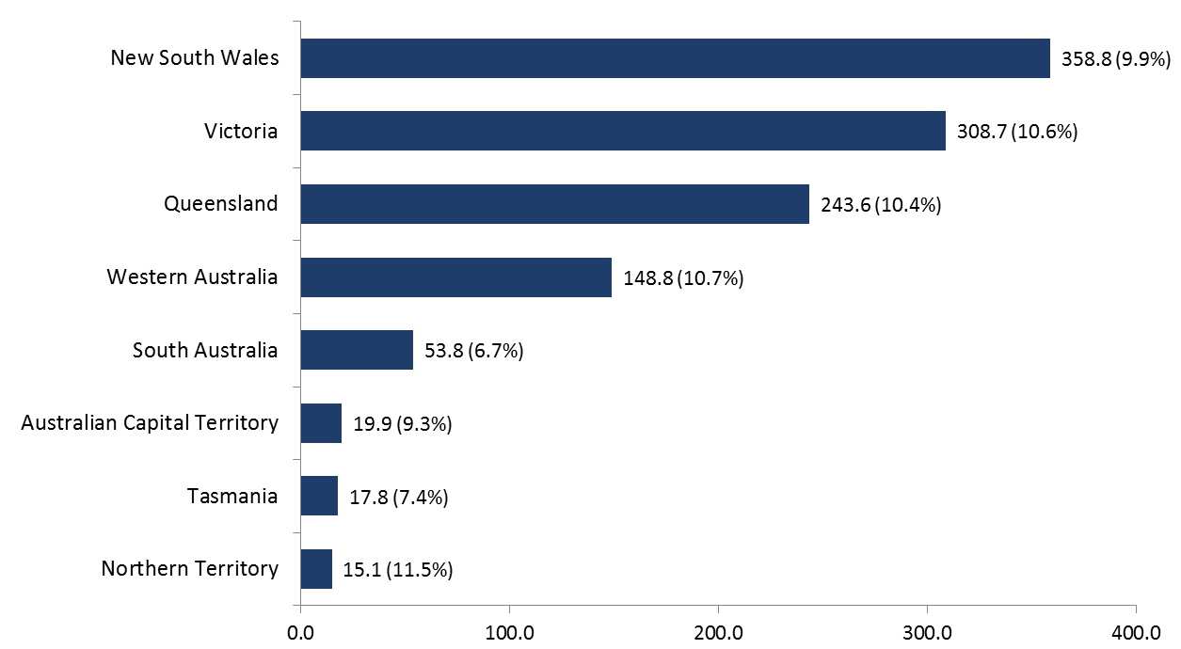

# Projected employment growth by region

Employment is projected to increase in all of the ABS SA4 Regions over the five years to November 2019. Employment in metropolitan areas is projected to increase by 10.7 per cent over the period, compared with 8.5 per cent projected for regional Australia. Of the metropolitan areas, employment growth is projected to be strongest in Darwin (up by 10,000 or 12.6 per cent) and Greater Perth (130,100 or 12.0 per cent), while below average growth is projected for Greater Adelaide (42,600 or 6.8 per cent) and Greater Hobart (8,600 or 8.1 per cent). Of the regional areas, employment growth is projected to be strongest in regional Queensland (115,800 or 9.8 per cent) and Northern Territory – Outback (5,000 or 9.7 per cent), just below the national average of 10.0 per cent. In contrast to the strong growth projected for Greater Perth, employment growth is projected to be weakest in Regional Western Australia (18,700 or 6.2 per cent), followed by Regional South Australia (11,200 or 6.4 per cent).

At the more detailed regional level, employment growth is projected to be strongest (in percentage terms) in Sydney - City and Inner South (up by 27,500 or 15.2 per cent) and Gold Coast in Queensland (45,000 or 15.5 per cent), while the largest projected increases in employment (in thousands) are for   
Melbourne –West (49,900 or 13.8 per cent) and Melbourne – South East (46,000 or 13.5 per cent). By contrast, employment growth is projected to be slowest, in percentage terms, in Queensland – Outback (1,100 or 2.2 per cent), Western Australia - Wheat Belt (3,000 or 4.5 per cent), and Victoria – North West (3,700 or 4.9 per cent).

**Figure 8: Projected employment growth by region – five years to November 2019 (%)**

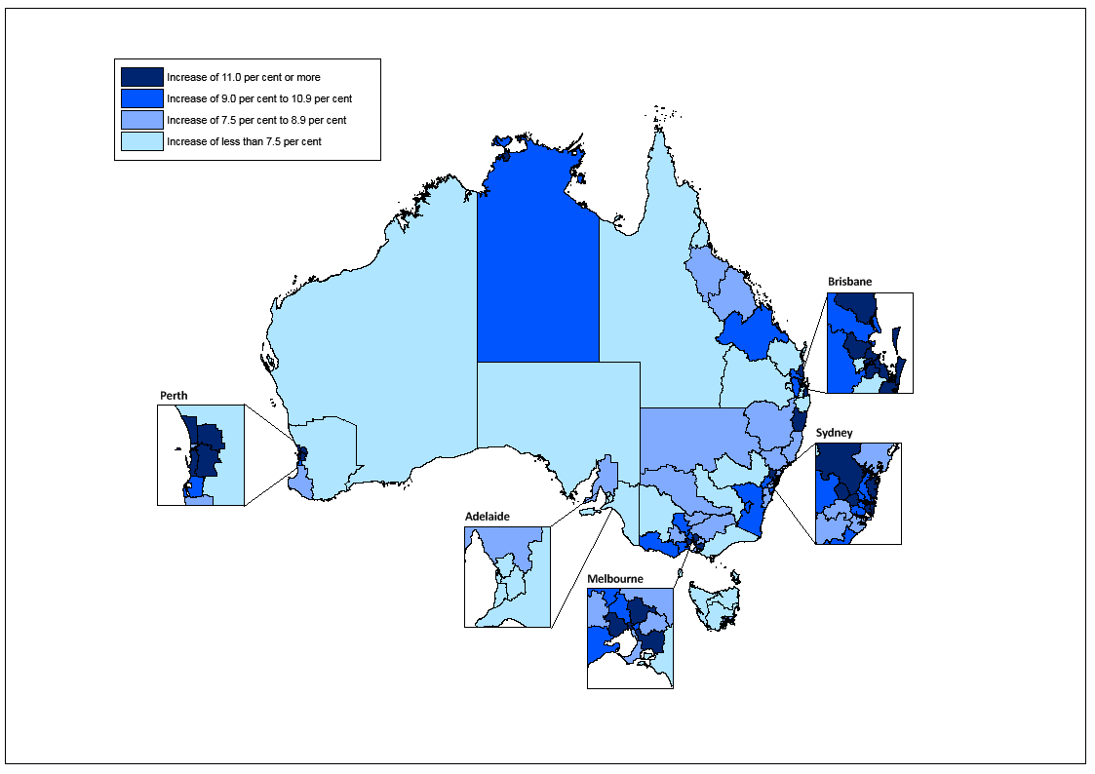

# Background and methodology

Each year, the Department of Employment produces employment projections by industry, occupation, skill level and region for the following five years, the latest being the five years to November 2019. These projections are designed to provide a guide to the future direction of the labour market. However, like all such exercises, they are subject to an inherent degree of uncertainty. While all efforts have been made to ensure these projections are as accurate as possible, due to the volatile nature of the data and the large number of very small series, caution should be exercised when using these projections.

The projections have been derived from best practice time series models that summarise the information that is in a time series and convert it into a forecast. The projections are made by combining forecasts from autoregressive integrated moving average (ARIMA) and exponential smoothing with damped trend (ESWDT) models, with some adjustments made to take account of research undertaken by the Department of Employment and known future regional and industry developments. These projections are produced using detailed data from the Australian Bureau of Statistics (ABS) Labour Force Survey, and do not reflect labour market developments since November 2014, the month of data upon which the projections are based. The projection for total employment growth is consistent with the Government’s forecasts and projections for total employment growth, as published in the latest Mid-Year Economic and Fiscal Outlook (MYEFO).

The projections for total employment by state and territory are not directly comparable with the forecasts and projections published in state and territory budgets, which typically have shorter forecast horizons and different base periods. The Department of Employment’s projections are also medium term and point-in-time projections, and are thus not indicative of expected employment growth in the short term.

Further information on Department of Employment’s projections, including downloadable spreadsheets, can be found at: <http://lmip.gov.au/default.aspx?LMIP/EmploymentProjections>

Additional labour market information can be obtained from the following links:

* Job Outlook ([joboutlook.gov.au](http://joboutlook.gov.au))
* Labour Market Information Portal (LMIP) (<http://lmip.gov.au>)
* Australian Jobs (<http://docs.employment.gov.au/system/files/doc/other/australian_jobs_2015.pdf>)

For further information, please contact Carmel O’Regan (02 6240 2599) or email **carmel.oregan@employment.gov.au**. Any media enquiries should be directed to the Department of Employment media unit (**media@employment.gov.au**).

Labour Market Research and Analysis Branch

Department of Employment

August 2015

1. All employment figures used in this analysis are trend series from ABS *Labour Force Survey, Australia* (Catalogue No. 6202.0 and 6291.0) unless otherwise stated. Latest available data on employment by industry and occupation are for May 2015.
2. All employment projections used in this analysis are Department of Employment Projections to November 2019.
3. Motor Vehicle and Motor Vehicle Part Manufacturing includes the manufacture of cars, vans, buses, trucks, trailers and caravans, as well as motor vehicle engines, bodies, electrical components and motor vehicle parts not elsewhere classified.
4. Other Mining Support Services includes directional drilling and redrilling; mining draining and pumping services; and oil and gas field support services.
5. Please note, in some cases relevant work experience may be a substitute for formal qualifications, or relevant work experience and/or on-the-job training may be required in addition to formal qualifications and training.