Estimates for the Button Wrinklewort (Rutidosis leptorrhynchoides) St Mark’s ACT

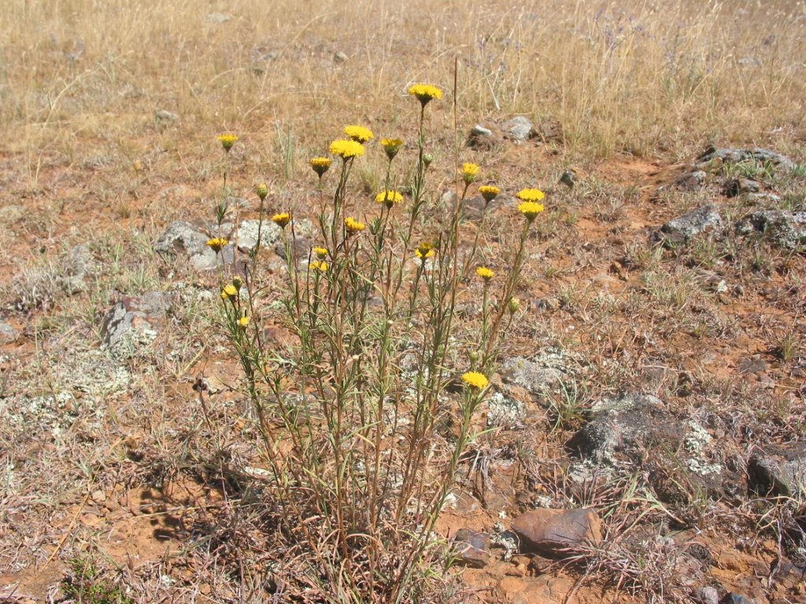

The Button Wrinklewort (Rutidosis leptorrhynchoides) is a native flora species, listed as endangered in the Australian Capital Territory, of the Asteraceae family.
It is found in the grassland of the Charles Sturt University Campus in Canberra, St Mark’s.
Conservation Research, ACT Government, have been monitoring the population of individuals at St Mark’s. The data they have supplied are estimates only, not census data and therefore, not an accurate representation of the individuals present to make any statistical claims.
It does appear from the estimate data that the population may be in a state of slow decline. This is likely due to demographic factors relating to the small population size. Rutidosis leptorrhynchoides has some unusual genetic traits that make it quite susceptible to small population pressures.
The estimate data is as follows:
1999: 100 – 200 plants
2002: 50-100 plants
2003: 100-200 plants
2007: 50-100 plants
2012: 25 – 50 plants
2015: 25-50 plants
2016: 25-50 plants

